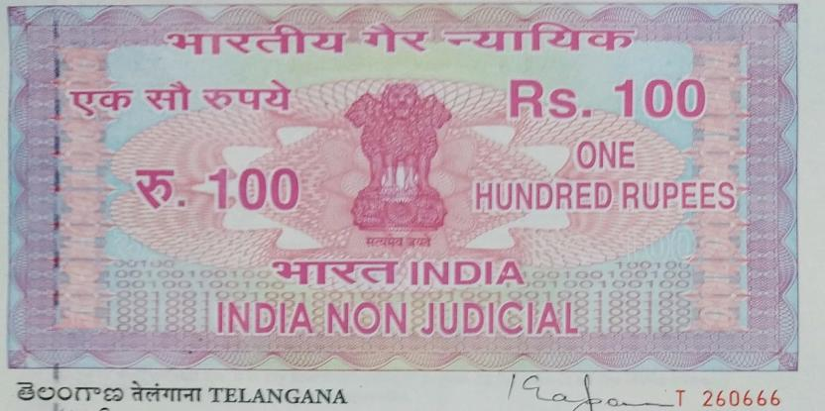

AFFIDAVIT BY THE STUDENT and PARENT

For VIII Semester students, who wants to attend Internship Program during VIII Semester of their class work and who have been selected through Training and Placement Office of CBIT(A).
I____________________________,Roll.No___________________________, of B.E/B.Tech ( ) VIII-Semester, S/o / D/o _______________________________, R/o____________________________________, hereby solemnly declare that I have been selected for _________________(Company name) through campus placements held on ________________, which is offering internship from ____________to _____________. I am willing to attend the Internship program and I do hereby accept the following conditions:

- I shall attend the classes on Saturdays in the College.

- I shall attend the department as and when it is required.

- I shall meet the respective subject mentors during non-Internship days, to clear my doubts, if any.

- I shall update the progress of the VIII - Semester project to my supervisor/guide/co-ordinator/Head of the department, from time to time.

- I shall submit that it is my sole responsibility to study the topics on my own for the following subjects which are missed in the regular class work during the internship period.

S. NO. | Subject Code | Title of the Subject
1
2
3
4
5
6
7
8
9

- It is my sole responsibility to complete the practical experiments of lab courses/project work either in my own Institute or in an institute/organization near to my internship workplace (the approval letter from the other Institute/organization shall be submitted).

- I shall get the evaluation of CIE of Lab Courses and Assignments& Slip Tests of Theory Courses from the respective faculty.
- I shall get the weekly attendance of the Internships attended and submit the same to the concerned HOD on every Saturday.

- I shall attend the mid-term examinations and semester end examinations as per the schedules notified by the Institute.

- I shall submit that it is my sole responsibility to pass on my own in all the above subjects and I shall not blame the institute otherwise.

- I shall attend the internship program as per the schedule specified by the industry/company and I shall update to T&PO /CDC and my department about the progress of the internship program.

- I submit that if I don’t meet the attendance requirements, as specified by the institute I will be detained for want of attendance.

- I shall attend the internship program regularly in the industry.

VERIFICATION

Verified that the contents of this affidavit are true to the best of our knowledge and no part of the affidavit is false and nothing has been concealed or misstated therein.

Verified at ……………………………… (Place) on this the ………….. (Day) of ……………… (Month) ………………. (Year) _________________________

Signature of Student

I understood the contents of this affidavit and promise to see that my ward abides by them.

Signature of the Parent

Solemnly affirmed and signed in our presence on this the ………. (Day) of …………. (Month) …………. (Year) after reading the contents of this affidavit.

Head, Dept. of _____  CBIT(A) | Director - CDC  CBIT(A) | Director – AEC & CoE  CBIT(A)

