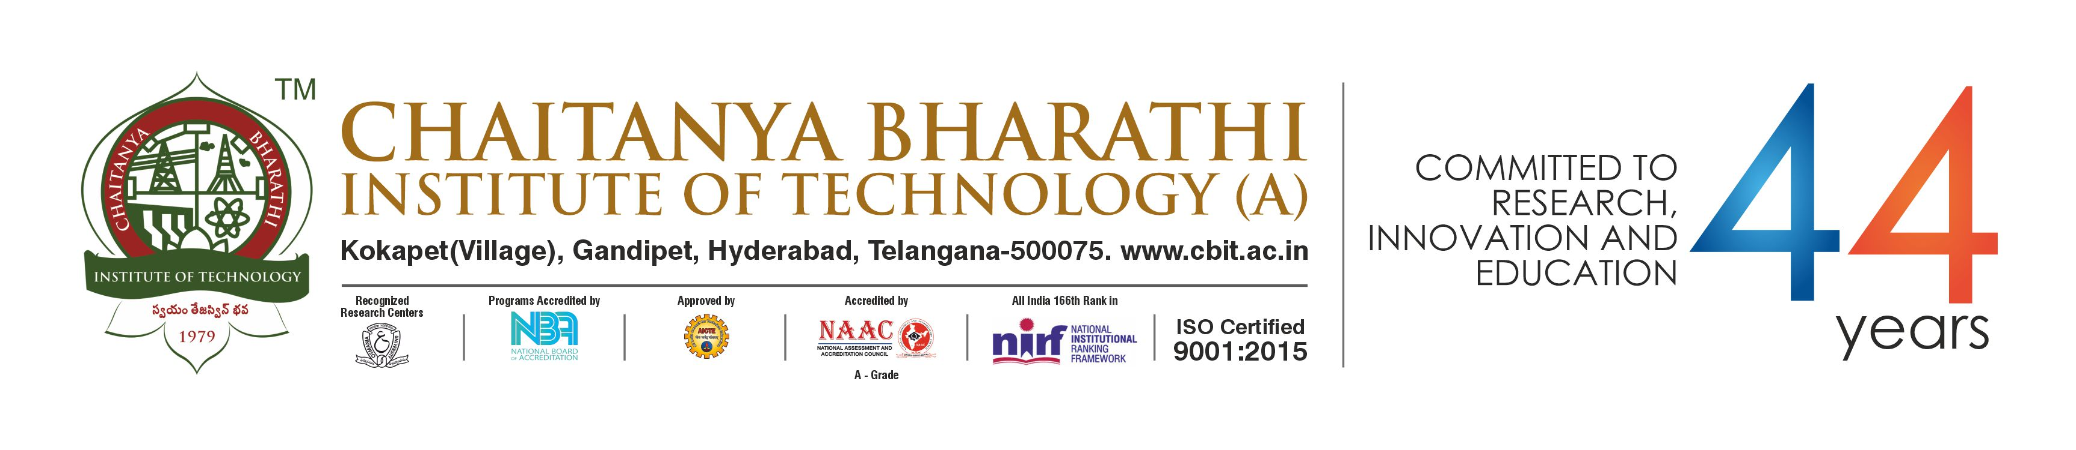

**Research and Development Centre**

**R&E Hub**

**4thResearch Day-2022**

(Hybrid mode)

**Saturday, 17 December 2022**

**10:00 AM – 5:00 PM**

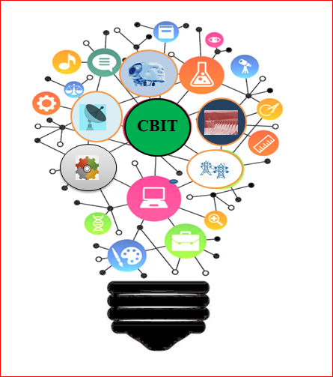

**Chaitanya Bharathi Institute of Technology**

(Autonomous under UGC)

Affiliated to Osmania University

Kokapet (Village), Gandipet,

Hyderabad – 500075

Telangana State, India.

[www.cbit.ac.in](http://www.cbit.ac.in)

**R&D Centre, CBIT**

**Celebrating the 4th Research Day**

**on**

**17 December 2022**

**General Guidelines**

* Abstracts are invited from Students, Research Scholars, Academicians and Industry Persons.
* The Abstract should be limited to a maximum of 300 words
* Submitted Abstracts should not have been previously published in any other conference, journal, book chapter etc.,
* Authors should satisfy the standard norms of plagiarism.
* All submitted Abstracts will be reviewed by expert committee members.
* Atleast one author should register for the Research Day 2022.
* E-Certificate will be provided through email only.
* All accepted, registered and presented abstracts will be published in e-Souvenir

**Events Registered for**

* Oral/Poster/Idea Presentation

<https://forms.gle/ypQZi9sZrcB6rVCW6>

**Registration Fee**

|  |  |
| --- | --- |
| **Category** | **Author (INR)** |
| Industry | Rs. 500/- |
| Faculty Member | Rs. 300/- |
| Research Scholar and Student | Rs. 200/- |
| Others | Rs400/- |

**Online Payment Details**

Acc. Name: CBIT Recurring Expenditure

Account Number: 180401001258

RTGS / NEFT IFS Code: ICIC0001804

**Organizing Committee**

**Chairperson**

**Dr. P.Ravinder Reddy**

Director & Head of R&E Hub

**Advisor**

**Dr. A.D. Sarma**

Director R&D

**Conveners**

|  |  |
| --- | --- |
| 1. | **Dr. M. Balasubbareddy**  Associate Professor, Dept. of EEE  Mobile: +91-9885308964 |
| 2. | **Dr. S. Shanmukharao Samatham**  Assistant Professor, Dept. of Physics  Mobile: +91-9630680607 |
| 3. | **Dr. D. Saritha**  Assistant Professor, Dept. of Chemistry  Mobile: +91-9591908844 |
| 4. | **Sri. K. Lakshmanna**  Senior Research Assistant, R&D Centre  Mobile: +91-9177935064 |

**For further details please contact:**

E-mail:[researchday@cbit.ac.in](mailto:researchday@cbit.ac.in)

**Important Dates**

|  |  |  |
| --- | --- | --- |
| Last Date for Submission | : | 18 November 2022 |
| Acceptance Intimation | : | 01 December 2022 |
| Last date for Registration | : | 07 December 2022 |
| Event/Presentations | : | 17 December 2022 |

Name:_________________________________

Designation:____________________________

Gender:________________________________

Organization:____________________________

Address for correspondence:________________

_______________________________________

_______________________________________

_______________________________________

Phone/Mobile:___________________________

Email:__________________________________

EducationalQualification:

Experience:

Category: Academic/Industry/R&D

Research Interests:

**Payment Details:**

Draft No: ______________ Date:___________

Amount: Rs.____________ Drawn on________

Place:

Date:

**About Research Day**

RESEARCH DAY, the focused initiative by the Institute is being Celebrated with an Objective to not only change the image from an Under Graduate Engineering College to Research focused Institute but also to expand the base to encourage Research Scholars, Students, Faculty to showcase their Research. The event facilitates the participants to network with faculty, fellow students and local industry who are sharing the same vision from India and abroad and learn the quality of Innovation - including the quality of scientific publications, the quality of Universities and patent related filings and recognize their own research while respecting others research in a Win-Win situation for all.

**Research Participants**

Each of the Participants interested to showcase their work should submit an Abstract of the Research papers not exceeding 300 Words in the prescribed format available in the registration form and submit the same on or before 20 August 2022. Exciting Prizes will be awarded to the best Research Papers under various Categories. For details, please visit the Website: [www.cbit.ac.in](http://www.cbit.ac.in)

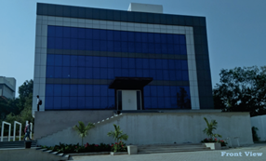

**R&E Hub Front View**

**Resource Persons**

Resource Persons will be from Renowned Institutions and Industry in India and Abroad.

**Emerging Areas to be Covered**

With a view to understand the impact of Government, Corporates, Educational Institutions, Investors on Innovation Ecosystem, the following areas will assume importance for extensive and intensive coverage:

1. Developing Entrepreneurship Capabilities
2. Establishing “Start Ups” – Experiences by

Promoters

1. Current Status of Research in Industries
2. Launching of Research based Projects

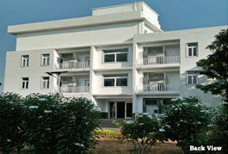

**R&E Hub Back View**

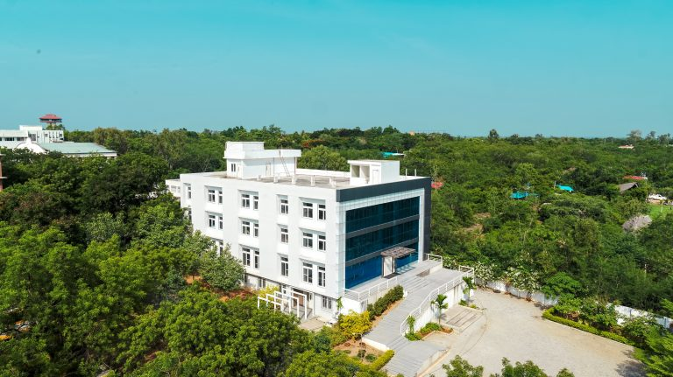

**R&E Hub Top View**

**ChaitanyaBharathi Institute of Technology (CBIT)**

CBIT is one of the premier Engineering Institutes in India, pioneer in Telangana State, which is at idyllic surroundings of Gandipet Lake, Hyderabad. The college offers Nine UG and Eleven PG programs. It has been standing as a temple of knowledge for the past 43 years by producing about 25,000 Eminent and skillful Graduate Engineers, who are successful in their Careers, serving all over the Globe. CBIT Students are prepared and perfected to secure Placements in reputed MNCs. The Institute has been accredited by NAAC – UGC with 'A' Grade and various programs are accredited by NBA – AICTE. The UGC has granted Autonomous Status from the Academic Year 2013-14 onwards. Stringent Academic Standards, Industry Compliant Teaching Methodology, Research Projects from Private and Public Sector organizations Industries in Engineering and Management and Consultancy Practice, enabled the Institute to establish its Identity in the Technical Education and is ranked as one of the best amongst the Private Engineering Colleges in both the Telugu Speaking States.

**About R and E Hub**

To enhance research activities and cultivate pleasant research atmosphere, a multi-crore state of the art building with all modern technical facilities was established in the year 2018. It facilitates all departments to carry out advanced research, establish incubation cells and start-ups. The R&E Hub, with its State-of-the-Art Infrastructure, helps to promote Research and Innovations amongst the Faculty and Students by identifying new Research Areas, developing Projects leading to Publications, Products, Innovations and Start-Ups. All research activities are being streamlined to make a mark in ‘Make in India’ concept of Indian Government.

It has two main wings namely Research and Development (R&D) Centre and Innovation and Incubation Center (IIC).