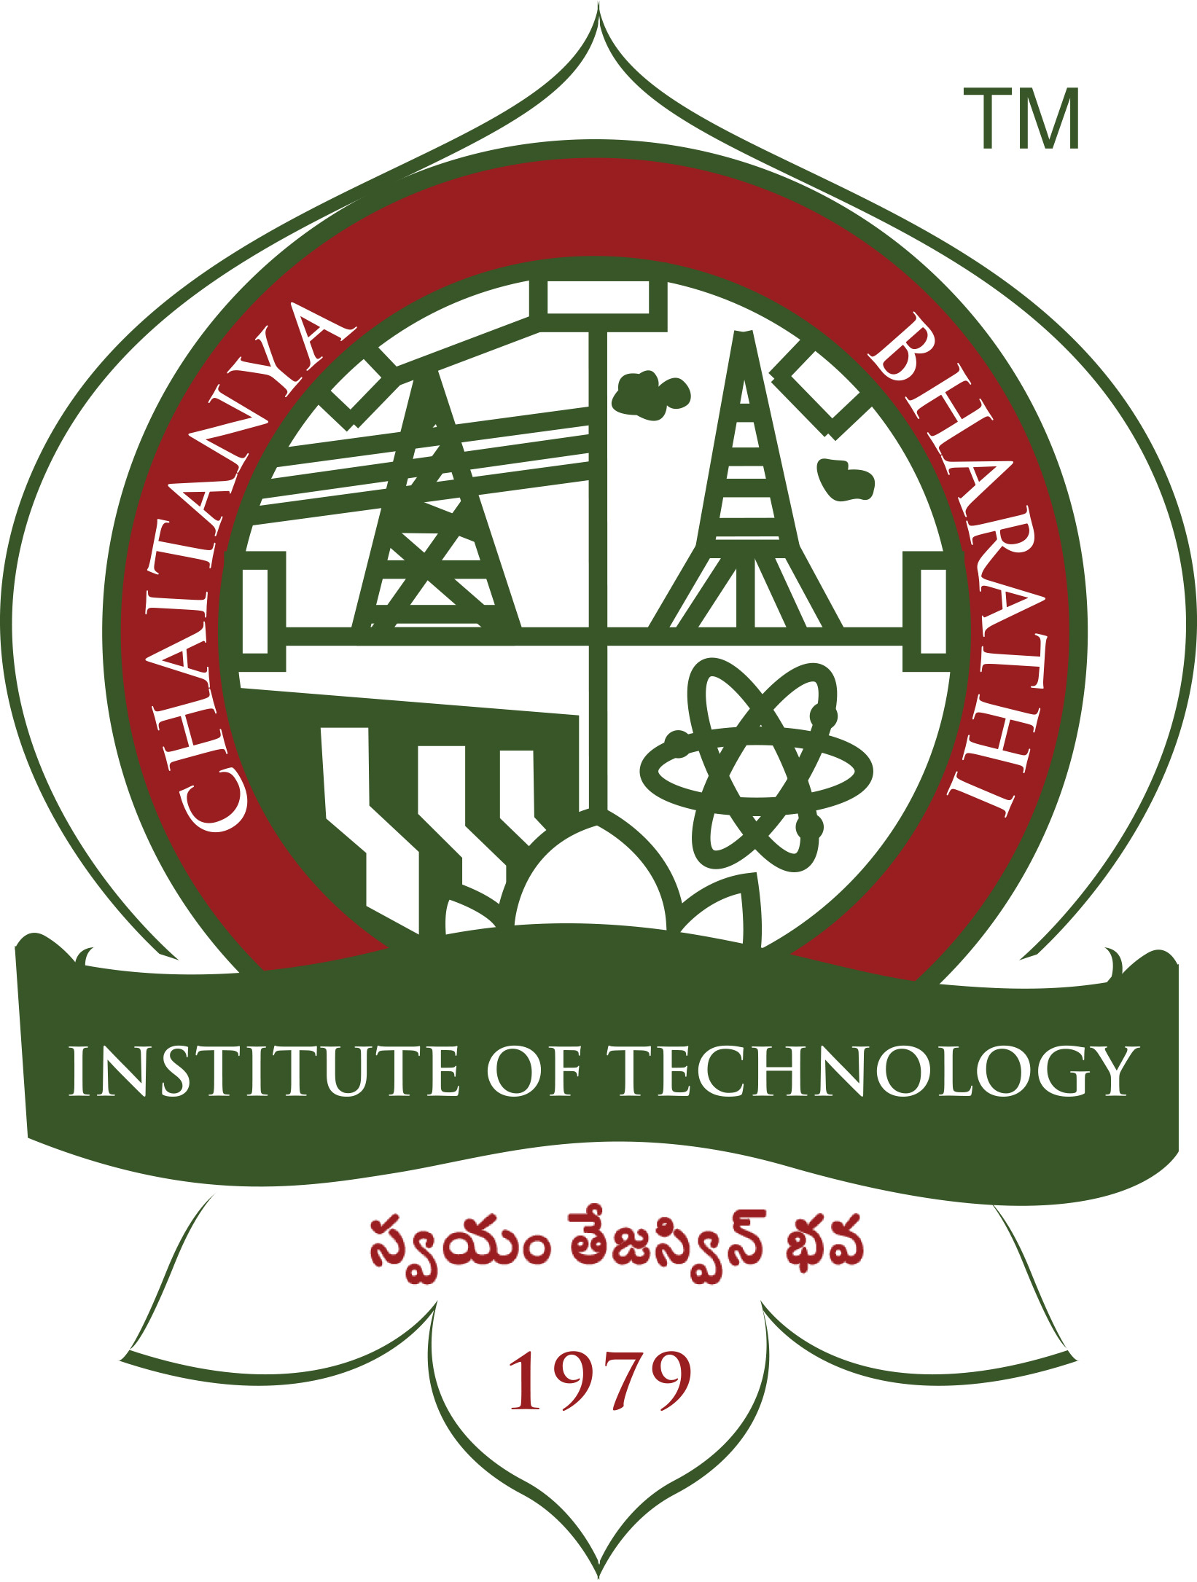 | CHAITANYA BHARATHI INSTITUTE OF TECHNOLOGY(A)  Affiliated to OU; Accredited by NBA; Accredited by NAAC-‘A’ Grade (UGC);  NIRF Ranked 100; ISO Certified 9001:2015  Gandipet, Hyderabad -500 075. Ph.040-24193276/79 Cell No.:8466997216.
M.E. /M.Tech SPOT ADMISSION NOTICE 2019-20
BRANCH WISE VACANCIES

S.No. | Branch | A-Category Vacancies | B-Category Vacancies | Total Vacancies
1 | M.Tech-Computer Science and Engg. | 11 | 9 | 20
2 | ME-Civil-Structural Engg. | 7 | 2 | 9
3 | ME-MECH-CAD/CAM | 9 | 5 | 14
4 | ME-MECH-Thermal Engg. | 6 | 3 | 9
5 | ME.-ECE-Embedded Systems and VLSI Design | 5 | 3 | 8
6 | ME-ECE-Communication Engg. | 4 | 5 | 9
7 | ME-EEE-Power systems and Power Electronics | 7 | 2 | 9
8 | M.Tech-IT-Computer Networks and Information Security | 5 | 5 | 10

Interested candidates who have not joined anywhere can report along with all original certificates for Spot Admission at CBIT on 16-09-2019 between 11.00 AM to 02.00 PM. The selected candidates have to pay Tuition Fee of Rs.1,51,600/- per year + Rs.7,500/- (Miscellaneous fee per year ). Admission will be made as per the guidelines of Convener TSPGECET-19 and TSCHE.

Scholarship for admitted candidates who have qualified either in GATE 2019 OR PGECET 2019

Scholarship: All admitted candidates who have qualified in TSPGECET 2019, having a rank between 1 to 400 will be given a scholarship amount of Rs.5000/- per month or Rs.60,000/- per annum and those having a rank between 401 to 800 will be given a scholarship amount of Rs.3000/-per month or Rs.36,000/- per annum provided by CBIT.

Scholarship (GATE Qualified Candidates):
All admitted candidates who have qualified in Gate 2019 are entitled for a scholarship amount of Rs.5000/- per month or Rs.60,000/- per annum provided by CBIT in addition to the scholarship amount provided to GATE qualified candidates by AICTE/MHRD, Govt. of India.

Date:13-09-2019 Sd/-
Place: Hyderabad Principal

