Conferences / Workshops / FDPs / Seminars
(From 16th June 2020 to 31st July 2020)

- Dr. B. Indira, Mr. P. Krishna Prasad, Mr. Ramesh Ponnala and Mr. C. N. V. B. R. Sri Gowrinath, actively participated in “TASK in association with EXCELR is conducting a virtual Faculty Development Program on Data Science” during 01st July 2020 to 24th July 2020.
- Dr. G. N. R. Prasad, participated actively in a Webinar on “Cyber Security” on 20th July 2020, organized by the department of Computer Science and Engineering, KMM Institute of Technology and Science, Tirupathi.
- Dr. G. N. R. Prasad, successfully completed an Online One Week FDP on “Optimization Techniques through Machine Learning for Wireless and IoT” conducted by Malla Reddy Engineering College for Women, Hyderabad during 13th July 2020 to 18th July 2020 and this FDP was sponsored by AICTE.
- Mr. D. Jayaram, participated in a One Week Online FDP on “Evolution of IOT and It’s Applications” , organized by the department of CSE, Mallareddy Institute of Technology and Science from July 13th to July 17th, 2020.
- Dr. B. Indira as one of the conveners, organized a one week National Level FDP on “Cyber Security”. This FDP was jointly organized by the department of CSE, MGIT and department of MCA, CBIT(A) in association with Supraja Technologies during 7th July, 2020 to 12th July, 2020.
- Department staff actively participated in a One Week National Level Online Faculty Development Program on “Cyber Security”, organized by Department of MCA, CBIT(A) and Department of CSE, MGIT in association with Supraja Technologies during 7th July, 2020 to 12th July, 2020.
- Mr. P. Krishna Prasad, Mr. B. Srinivasa S. P. Kumar, Mr. Ramesh Ponnala and Mr. C. N. V. B. R. Sri Gowrinath participated in a Two week Online Faculty Development Program on “Internet of Things”, organized by Department of ECE, Vikas College of Engineering and Technology during 27th June 2020 to 10th July 2020.
- Dr. G. N. R. Prasad, participated actively in a Webinar on “Machine Learning using R” on 06th July 2020 organized by the department of Computer Science and Engineering, University College of Engineering, BIT Campus, Anna University, Tiruchirappalli.
- Dr. B. Indira, Mr. Ramesh Ponnala and Mr. C. N. V. B. R. Sri Gowrinath were participated in a Two Week online Faculty Development Program on “PYTHON” conducted by the Department of Electronics and Communication Engineering, JSS Academy of Technical Education, Noida and Spoken Tutorial Project IIT Bombay funded by National Mission on Education through ICT, MHRD, Govt of India during 22nd June 2020 to 05th July 2020.
- Dr. G. N. R. Prasad, participated in a Two Day Online FDP on “Recent Technologies and Trends in Computer Science and Information Technology ” organized by Department of Information Technology, Oriental Institute of Science and Technology(OIST), Bhopal from 04th July 2020 to 05th July 2020.
- Mr. M. Kalidas as one of the coordinators, organized a One week refresher course “Bharatiya Chaitnyam”, conducted by Geervana Bharati – CBIT from 29th June 2020 to 05th July 2020.
- Dr. G. N. R. Prasad had successfully completed an Online Symposium on “Quantum Information & Computation (quantum talks)” conducted during 29th June to 03rd July 2020 in IIIT Hyderabad..
- Dr. D. L. Sreenivasa Reddy, participated in a One week FDP on “Role of Machine learning and Data Science”, during 28th June to 02nd July 2020.
- Dr. B. Indira, Mr. Ramesh Ponnala and Mr. C. N. V. B. R. Sri Gowrinath were Participated in a five day Faculty Development Program on “NATURAL LANGUAGE PROCESSING BEHIND DATA SCIENCE” presented by Codegnan IT solutions, in association with department of CSE, Bonam Venkata Chalamayya Institute of Technology & Science during 22nd June 2020 to 26th June 2020.
- Mr. C. N. V. B. R. Sri Gowrinath, Mr. Ramesh Ponnala and Dr. B. Indira successfully completed Amrita - Hebeon Online Webinar cum Workshop on “Data Science using Python” for faculty members using Microsoft Teams Platform organized by Amrita College of Engineering and Technology, Nagercoil and Hebeon Technologies, Hyderabad during 17th June 2020 to 25th June 2020.
- Mr. D. Jayaram and Mr. P. Krishna Prasad were participated in a Webinar on “Publishing Research Articles in Scopus Indexed Journals” conducted by CBIT - School of Management Studies on June 24th, 2020.
- Mr. P. Krishna Prasad, successfully completed “The Bodhi Tree and SAFE Tools for Effective Online Teaching: A Hands-On Workshop” on 21st June 2020, organized by Teaching Learning Centre (ICT) at IIT Bombay, funded by the Pandit Madan Mohan Malaviya National Mission on Teachers and Teaching (PMMMNMTT), MHRD, Govt. of India
- Mr. D. Jayaram and Mr. P. Krishna Prasad were participated in a One week FDP on “Intelligent Computing in Data Science” organized by the department of CSE Adiya Institute of Technology and management (A), Tekalli, AP from 16th June 2020 to 20th June 2020.
- Dr. B. Indira, participated in a One Week Faculty Development Programme on “Next Generation Software Tools & Trends for Industrial Solutions: Current Practices” conducted by department of Computer Science and Engineering, Government College of Engineering, Aurangabad during 13th June 2020 to 17th June 2020.
- Our department staff participated in a One day Workshop on “Social Responsibility and Community Engagement” organized by CBIT(A) on 17th June 2020.
- Dr. B. Indira, participated in a Two week Faculty Development Programme on “Multimedia and Drawing” organized by Department of Computer Science, Government First Grade College, Harihara in association with spoken tutorial IIT Bombay (An Initiative of National Mission on Education through ICT, MHRD, Govt. of India) under the scheme of PMMMNMTT during 03th June 2020 to 16th June 2020.
- Dr. B. Indira and Mr. M. Ramchander were participated in a Faculty Development programme on “Technology Towards Common Man” conducted by department of Instrumentation and Control Engineering, Sri Manakula Vinayagar Engineering College, Puducherry during 10th June 2020 to 13th June 2020.
- Dr. B. Indira, participated in a One week National online Faculty Development programme on “Python Programming” organized by Dept. of Computer Science, Government College For Women, Kolar, Karnataka in association with Spoken Tutorial IIT-Bombay 05th June 2020 to 11th June 2020.
- Dr. B. Indira, participated in a two day online FDP on “Effective Technical Report Writing using Latex” organized by Department of Electronics and Communication Engineering , MGIT, Hyderabad during 08th June 2020 to 09th June 2020.
- Dr. B. Indira, participated in a One week National level online Faculty Development programme on “Internet of Things and Artificial Intelligence Applications” organized by Department of Computer Engineering, KL Deemed to be university, Guntur 01th June 2020 to 06th June 2020 .
- Dr. B. Indira, participated in an online Faculty development programme on “IoT, AI & ML: Industrial Perspective” Organized by the Department of Electronics and Communication Engineering, Sri Venkateswara College of Engineering and Technology (Autonomous), Chittoor 05th June 2020 to 07th June 2020.
- Dr. B. Indira, participated in an online Faculty programme on “Outcome Based Education” by Sri Mankula Vinayagar Engineering College, Puducherry 05th June 2020 to 06th June 2020.
- Department staff had registered and actively participated in various Online Webinars.

(From 1st January 2019 to 15th June 2020)
- Department faculty, actively participated in a One day online workshop on “Social Responsibility and Community Engagement” conducted by CBIT on 17th June 2020.
- Dr. D. Lakshmi Sreenivasa Reddy, participated in a one week ATAL FDP on Artificial Intelligence in May 2020.
- Dr. G. N. R. Prasad, participated in a one week ATAL FDP on Artificial Intelligence in May 2020.
- Mr. M. Ramchander as one of the coordinators, organized a 5-day National level FDP program on Artificial Intelligence, organized by departments of CSE, IT and MCA of CBIT in collaboration with Brain-O-Vision India Pvt. Ltd. During 22nd -26th May 2020. Department faculty actively participated in this FDP.
- Dr. D. Lakshmi Sreenivasa Reddy, participated in a one week FDP on online course on Examination Reforms-AICTE in April/May 2020.
- Dr. B. Indira, Mr. P. Krishna Prasad, Mr. Ramesh Ponnala and Mr. C N V B R Sri Gowrinath, were participated in a 3-day online Faculty Development programme on “Effective and Efficient Online Teaching in the Age of Corona, A Hands On Workshop” through BodhiTree platform, organized by IIT Bombay in the month of May 2020.
- Dr. B. Indira, participated in various IPR related online workshops in the month of May 2020.
- During the pandemic situation COVID-19, the department staff have attended for various Faculty Development Programs to get more exposure on emerging technologies and are related to:
- Outcome Based Education (OBE)
- PHP and MySQL
- Internet of Things
- Machine Learning
- Artificial Intelligence
- Big Data
- Python
- Data Science
- R Programming
- HTML and so on
- Department staff attended for various Short Term Training Programs on various domains in the month of May 2020.
- Mr. M. Ramchander & Mr. P. Krishna Prasad, organized a Two Day National Hands-on Workshop on “Python Programming for Engineering Applications” during 26th – 27th July 2019. The venue of the workshop was Placement cell labs, CBIT. The Resource Persons of the Workshop were Mr. Anup Jayant Kelkar & Mr. Darshan Nakhate, Springboard, Nagpur. The workshop provided Hands-on expert guided training, Access to Python power-points, research papers and other learning resources, Opportunity to interact with industry experts for career guidance. Total participants for the workshop were 85 (23 Staff members and 62 Students).
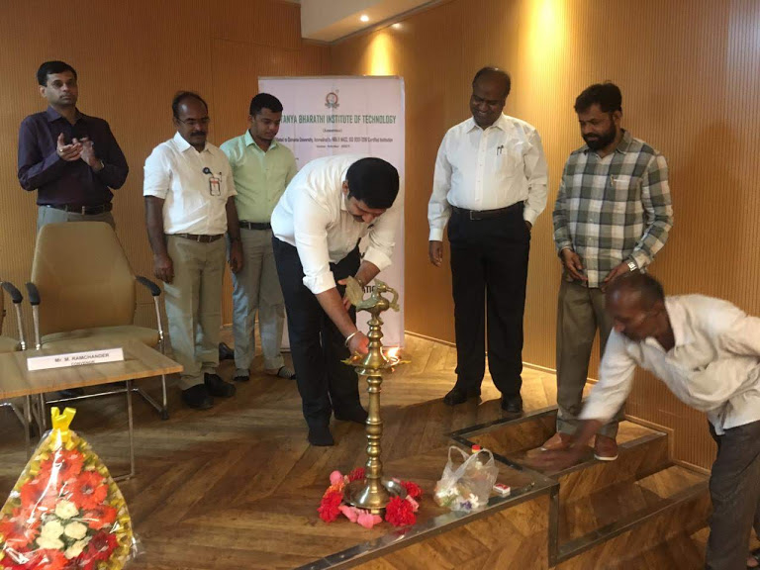
CBIT(A), DEPT. OF MCA, TWO DAY WORKSHOP ON PYTHON PROGRAMMING FOR ENGINEERING APPLICATIONS, 26th -27th JULY 2019
The Principal - CBIT, HOD of MCA, Speakers and faculty at the Inaugural of the Workshop

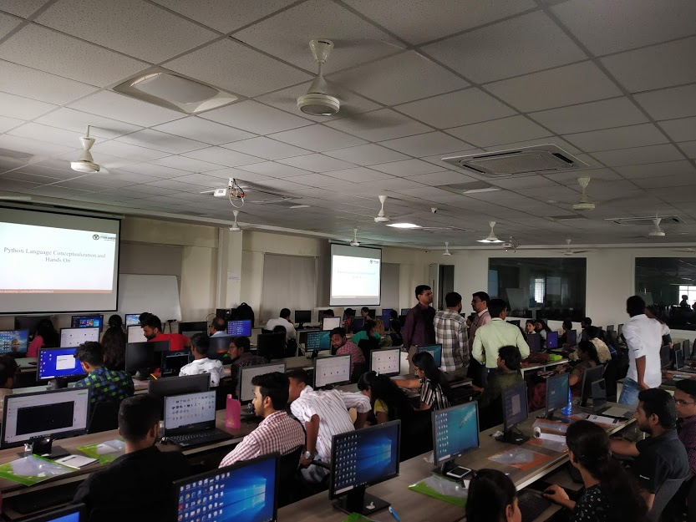
CBIT(A), DEPT. OF MCA, TWO DAY WORKSHOP ON PYTHON PROGRAMMING FOR ENGINEERING APPLICATIONS, 26th -27th JULY 2019
Students working on Python programming
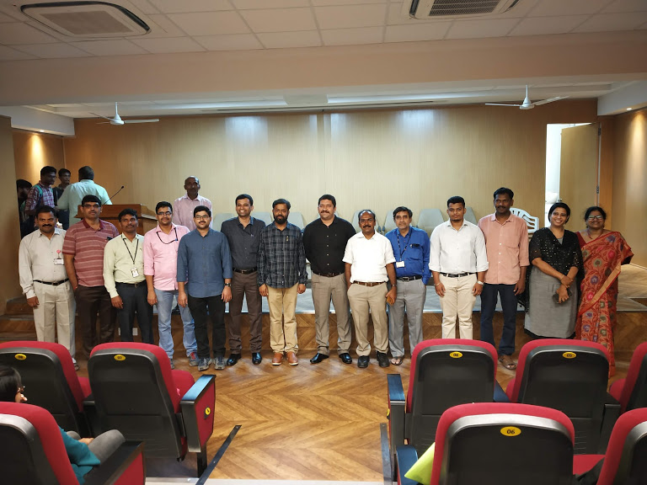
CBIT(A), DEPT. OF MCA, TWO DAY WORKSHOP ON PYTHON PROGRAMMING FOR ENGINEERING APPLICATIONS, 26th -27th JULY 2019

MCA staff at Valedictory Function of two day workshop on Python Programming for Engineering Applications
- Mr. G. N. R. Prasad, organized a One Day national workshop on “Software Testing” on 16th March 2019 and the venue was C-203 Seminar hall, CBIT. The speakers of the Workshop were Mr. I. Surya Prakash & Mr. B. Srihari, Tech Mahindra, Hyderabad. They spoke about various Skills required to become a Software Tester. Some of the skills are Analytical skills, Communication skill, Time Management & Organization Skills, Great Attitude and Passion and some software testing tools like Selenium and HP Quick Test Pro. Total participants for the workshop were 94 (12 Staff members & 82 Students).
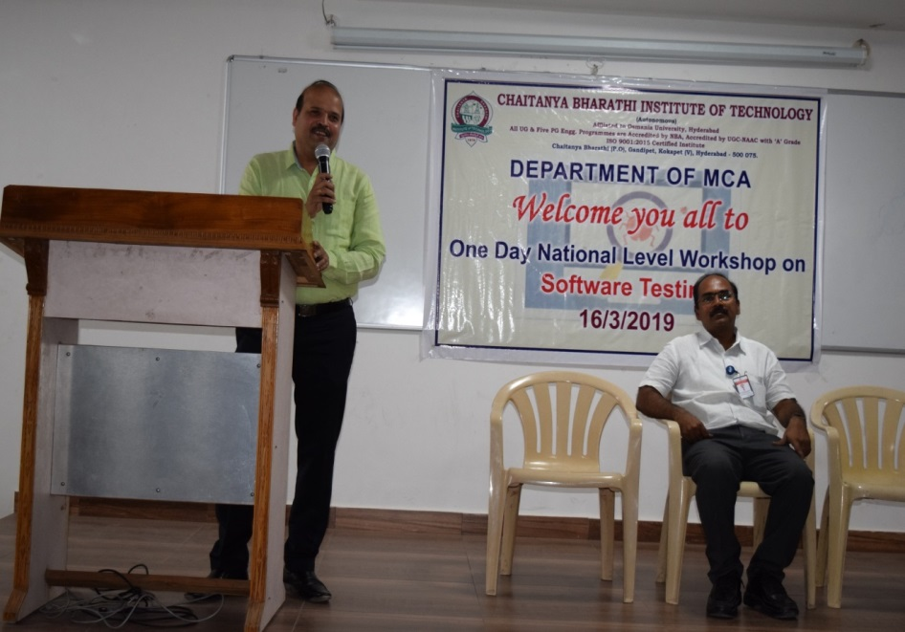
CBIT(A), DEPT. OF MCA, ONE DAY WORKSHOP ON SOFTWARE TESTING, 16TH MARCH 2019
Speaker Mr. I. Surya Prakash delivering the lecture on Software Testing
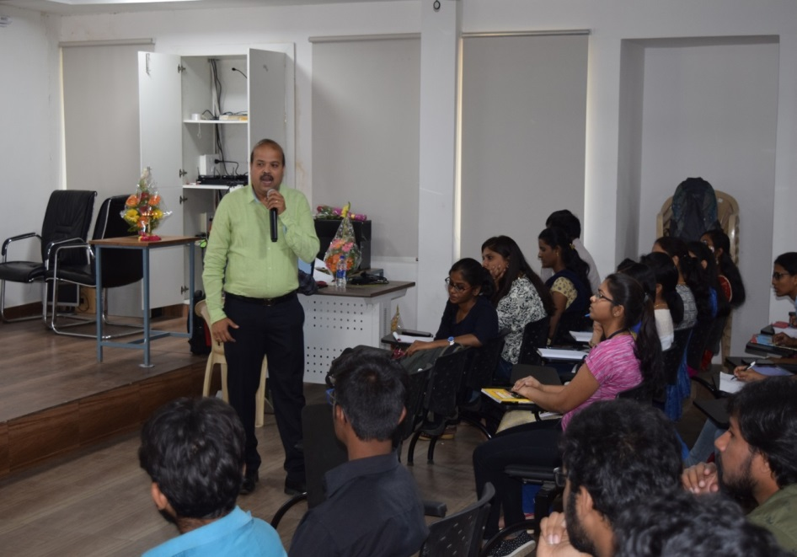
CBIT(A), DEPT. OF MCA, ONE DAY WORKSHOP ON SOFTWARE TESTING, 16TH MARCH 2019
Speaker Mr. I. Surya Prakash interaction with students during his lecture

Online Courses / Training Programs
Registered and completed by Staff
(From 16th June 2020 to 31st July 2020)
- Mr. C. N. V. B. R. Sri Gowrinath, enrolled and successfully completed the online non-credit course “Neural Networks and Deep Learning”, in the month of July 2020. This course was offered through Coursera and authorized by deeplearning.ai.
- Mr. C. N. V. B. R. Sri Gowrinath, enrolled and successfully completed the online course “Applied Plotting, Charting and Data Representation in Python”, offered by Coursera in association with University of Michigan and successfully completed in the month of July 2020.
- Mrs. T. S. Praveena had completed 3 courses in “Block Chain Specialization, AI for everyone” from Coursera L4G programme during June – July 2020.
- Dr. B. Indira, participated in a Five day Online Short Term Training Program on “Recent Trends in Data Science and Information Security” conducted by RAIT, Navi Mumbai, Maharashtra during 22nd June 2020 to 26th June 2020.
- Mrs. T. S. Praveena, attended a five day online Technical Training Programme on “Block Chain”, conducted by ETE - Mumbai in association with Pantech E-Learning during 22th June 2020 to 26th June 2020.

(From 1st January 2019 to 15th June 2020)
- Dr. B. Indira, participated in a Short course on “Learn to Design Your Own Solar Home System” as part of Energy Literacy Drive of the Energy Swaraj Foundation on 13th June 2020.
- Dr. B. Indira, participated in a Short Term Training on “Internet Of Things” conducted by Apptronix Technologies in collaboration with A.G Patil Institute of Technology, Solapur 01th June 2020 to 07th June 2020.
- The staff of MCA department have concentrated on emerging technologies by registering and completing courses successfully using Coursera certification programme related to the domains – Python, Machine Learning, Cloud Computing, Deep Learning, Neural networks, Artificial Intelligence, C++ and other.
- Mr. C N V B R Sri Gowrinath, participated and got certificate in “Machine Learning Using Python” course from Skyfi Labs (Learn Engineering Practically) in the month of June 2020.
- Mr. Ramesh Ponnala, participated and got certificate in “Machine Learning Using Python” course from Skyfi Labs (Learn Engineering Practically) in the month of May 2020.
- Dr. B. Indira, Mr. P. Krishna Prasad, Mr. Ramesh Ponnala and Mr. C N V B R Sri Gowrinath, were participated in a 3-day online Faculty Development programme on “Effective and Efficient Online Teaching in the Age of Corona, A Hands On Workshop” through BodhiTree platform, organized by IIT Bombay in the month of May 2020.
- Dr. B. Indira, participated in a one week online Faculty Development programme on “Introduction to Computers” by Shriram Institute of Engineering & Technology Centre, Paniv during 20th May 2020 to 24th May2020.
- Dr. B. Indira, participated in an online Faculty Development programme on “Artificial Intelligence and Machine Learning” organized by Dept. of Computer Science, CMRTC, Hyderabad during 18th May 2020 to 22nd May 2020.
- Dr. B. Indira, participated in an Online FDP on "Machine Learning and Its Applications" organized by EICT IIT Roorkee during 05th May 2020 to 14th May 2020.
- Our department faculty actively participated in various online courses under SoloLearn during COVID-19.
- Dr. B. Indira and Mr. Ramesh Ponnala, participated in “Foundations to Open Education and OERs Repositories” organized by UNED Abierta in association with IEEE Education Society in the month of April 2020.
- Dr. B. Indira, actively participated in “Orientation Program on Examination Reforms-AICTE guidelines – OBE Framework” conducted by IT Dept, CBIT on 29th April 2020.
- The department faculty completed their internal assessments of various NPTEL courses and waiting for the final examination conduction.
- All the faculty members participated in various online Webinars by MHRD, IIC, MIC and others. Also took participation in NPTEL lecture series.
- Department staff actively participated in various online quiz programs to refresh their knowledge.

Registered and completed by Students
(From 16th June 2020 to 31st July 2020)
- Arvind Yede has successfully completed “Programming for Everybody (Getting started with Python)” on 28th July 2020, the course was an online non-credit course authorized by University of Michigam and offered through Coursera.
- Anjali Kumari has successfully completed the “SQL Fundamentals” course on 27th July 2020 and the course was offered by SoloLearn.
- Deepthi P has successfully completed the “Data Science with Python” course on 24st July 2020. The course was offered by SoloLearn.
- Priyanka Kuntala has successfully completed “Java Tutorial course” on 23rd July 2020. The course was offered by SoloLearn.
- Baswaraj Mahesh has successfully completed “Technical Support Fundamentals” on 22nd July 2020, the course was an online non-credit course authorized by Google and offered through Coursera.
- Priyanka Kuntala has successfully completed the online, non-credit Specialization (5 Courses) “Python for Everybody” on 22st July 2020. The course was authorized by University of Michigan through Coursera.
- Deepthi P has successfully completed the “CSS Fundamentals” course on 21st July 2020, offered by SoloLearn.
- Deepthi P has successfully completed the “SQL Fundamentals” course on 20th July 2020. The course was offered by SoloLearn.
- Sanjay Appidi has successfully completed “Python Programming Foundation” training on 17th July 2020 offered by Apponix.
- Pasala Divya Jyothi has participated in the Webinar “Robotics Operating System” on 17th July 2020 hosted by Adama Science & Technology University, Ethiopia in association with Pantech.
- Uday Pothana has successfully completed “Use WordPress to Create Blog for your Business” on 17th July 2020, the course was an online non-credit course authorized by Coursera Project Network and offered through Coursera.
- Sanjay Appidi has successfully completed an Eight weeks online training on “Android App Development” from Internshala Trainings on 12th July 2020.
- Pasala Divya Jyothi has participated in the Webinar “Object Recognition\Yolo\Mobile Net\Cloud” on 10th July 2020 hosted by Khalsa College for Women Sidhwan khurd, Ludhiana in association with Pantech.
- Sanjay Appidi has successfully completed Mobile App Development Program offered by e-flip for the duration of 6 weeks and the certificate was issued on 10th July 2020.
- Rishabh Arvind Verma has successfully completed “Python basics” on 9th July 2020, the course was an online non-credit course authorized by University of Michigan and offered through Coursera.
- Pasala Divya Jyothi has participated in the Webinar “Natural Language Processing” on 07th July 2020 hosted by Siddhartha Institute of Technology & Sciences in association with Pantech.
- Gaddameedi Vishwakumar has participated in the Technical training program on “Python Programming” from 29th June 2020 to 03rd July 2020. The course was conducted by IETE – Mumbai in association with Pantech E Learning.
- Patham Ajay has participated in the Technical training program on “Python Programming (Code I)” from 29th June 2020 to 03rd July 2020. The course was conducted by IETE – Mumbai in association with Pantech E Learning.
- Baswaraj Mahesh has successfully completed course in “Machine Learning with AI using Python” from Knowledge Solutions India on 02nd July 2020.
- Baswaraj Mahesh has successfully completed “Capstone: Retrieving, Processing and Visualizing Data with Python” on 2nd July 2020, the course was an online non-credit course authorized by University of Michigan and offered through Coursera.
- Ankit Kumar Pradhan has successfully internship in Discover Technologies during 25th May 2020 to 02nd July 2020.
- Lohit Kumar Roy has successfully completed all requirements and is certified as a Ranksheet “Professional – Level 1 in Mobile Technology Basics and scored 90/100” in the month of July 2020.
- Lohit Kumar Roy has successfully participated and scored 67% in online quiz competition conducted by the Department of Master of Computer Application, St. Ann’s College for Women in the month of July 2020.
- Deepthi P has successfully participated and scored 73% in online quiz competition conducted by the Department of Master of Computer Application, St. Ann’s College for Women in the month of July 2020.
- Arvind Yede has successfully completed “Machine Learning Pipelines with Azure ML Studio” on 30th June 2020 and the course was an online non-credit course authorized by Coursera Project Network and offered through Coursera.
- Pasala Divya Jyothi has participated in “Spit-free India Movement” during Jun – Aug 2020 to spread the prevent of COVID-19 organized by Sambandh Health Foundation.
- Rushikeswara Rao Tulala has successfully completed the online, non-credit Specialization (5 Courses) “Python for Everybody” on 29th June 2020, the course was authorized by University of Michigan through Coursera.
- Mahesh Baswaraj has participated in a Three Days online Workshop on “Data Science and Machine Learning” organized by the Department of Information Technology, Sri Venkateswara College of Engineering, Sriperumbudur, from 26th to 28th June 2020.
- Bommireddy Karthik Saikumar Reddy has successfully completed and received a passing grade on 26th June 2020 in “Introduction to Data Science”, a course on cognitiveclass.ai powered by IBM Developer Skills Network
- Sanjay Appidi has participated in the Technical training program on “Python Programming (Code A)” from 22nd June 2020 to 26th June 2020. The course was conducted by IETE – Mumbai in association with Pantech E Learning.
- Deepthi P has participated in the “National Level Online Coding Competition (Round – 1)” on 26th June 2020, organized by IEEE Student branch – GIET University & IEEE Bhubaneswar subsection in association with HackerRank.
- Dhanush Reddy has participated in the Technical training program on “Python Programming (Code A)” from 22nd June 2020 to 26th June 2020. The course was conducted by IETE – Mumbai in association with Pantech E Learning.
- Bommireddy Karthik Saikumar Reddy has successfully achieved “The Fundamentals of Digital Marketing” certification on 26th June 2020, offered by Google Digital Garage.
- Deepthi P has given wonderful performance and scored 72% in the Quiz organized by the Department of Computer Science, Telangana Social Welfare Residential Armed Forces Preparatory Degree College for Women, Bhongir on 25st June 2020.
- Bommireddy Karthik Saikumar Reddy has successfully completed and received a passing grade on 25th June 2020 in “Python 101 for Data Science”, a course on cognitiveclass.ai powered by IBM Developer Skills Network
- Priyanka Kuntala has successfully cleared the assessment for the skill “Problem Solving (Basic)” on 24th June 2020, offered by HackerRank.
- Sanju Reddy has successfully completed an Internship programme on “Data Science” in Exposys Data Labs from 23rd May 2020 to 24th June 2020.
- Bommireddy Karthik Saikumar Reddy has successfully completed “GIT Tutorials for Beginners” on 22nd June 2020 offered by BitDegree.
- Bommireddy Karthik Saikumar Reddy has successfully completed “Django Deployment on DigitalOcean Made Easy” on 22nd June 2020 offered by BitDegree.
- Bommireddy Karthik Saikumar Reddy has given wonderful performance and scored 76% in the Quiz organized by the Department of Computer Science, Telangana Social Welfare Residential Armed Forces Preparatory Degree College for Women, Bhongir on 21st June 2020.
- Lohit Kumar Roy has successfully all requirements and is certified as a Ranksheet “Professional – Level 1 in Web Technology Basics and scored 60/100” in the month of June 2020.
- Uday Pothana has successfully completed “Advanced Relational Database and SQL” on 18th June 2020, the course was an online non-credit course authorized by Coursera Project Network and offered through Coursera.
- Uday Pothana has successfully completed “Introduction to HTML5” on 16th June 2020, the course was an online non-credit course authorized by University of Michigan and offered through Coursera.
- Mahesh Baswaraj of MCA, completed “Python Developer in 2020: Zero to Mastery” online course on 17th June 2020.
- B. Karthik SaiKumar Reddy has actively participated in a one day online workshop on “Social Responsibility and Community Engagement” conducted by CBIT on 17th June 2020.

(From 1st January 2019 to 15th June 2020)
- Students of MCA were enrolled and completed/completing various online courses offered by Coursera during COVI-19.
- Mahesh Baswaraj, participated and successfully cleared the assessment for the skill of Python (Basics) in HackerRank Certification program on 14th June 2020.
- P. Divya Jyothi, participated in Josh Scholarship test conducted by Ethnus in June 2020.
- Students of MCA completed online courses such as Python, Data Science, Java, jQuery, SQL, C++, C, PHP, HTML and these courses offered by SoloLearn platform.
- B. Charan, has attended bootcamp on online Full Stack Web Development and attended AI & ML workshops online.
- Some students of MCA registered in various NPTEL courses and awaiting for external examination.
- Deepthi P has successfully completed her “Online Talent Fest for IT Students” on 23rd May 2020 with 80%, organized by the department of Information Technology, School of Computing Sciences, VISTAS, Chennai.
- The students of MCA actively participated in various online quiz programs to assess their level of attainment during COVID-19.
- M. Sucharitha Reddy of MCA IV semester, attended for various seminars conducted in our college.
- B. Karthik SaiKumar Reddy, successfully completed a free online course on “Computer Vision Essentials” offered by Great Learning Academy in the month of May 2020.
- Alekhya Rumandla, successfully completed “Career Edge- Knokdown the Lockdown” on 19th May 2020 and the course offered by TCSiON.
- B. Karthik SaiKumar Reddy, successfully completed a free online course on “Introduction to Ethical Hacking” offered by Great Learning Academy in the month of May 2020.
- Rishab Verma actively participated in a two day online academic enrichment program “Cloud Computing and its real world applications” from 16th May 2020 to 17th May 2020. The program was organized by Alumni Association of Vaagdevi College of Engineering (VCE), Department of Computer Science and Engineering, Vaagdevi Incubation and Business Accelerator (VIBA).
- B. Karthik SaiKumar Reddy, successfully completed a free online course on Artificial Intelligence in Python offered by Great Learning Academy in the month of May 2020.
- Mahesh Baswaraj has taken part in Quiz on “Basics of Computer Network” on 06th May 2020 and has secured 80%. The program was conducted by Department of Collegiate Education, Maddur, Karnataka.
- Deepthi has taken part in Quiz on “Basics of Computer Network” on 06th May 2020 and has secured 93%. The program was conducted by Department of Collegiate Education, Maddur, Karnataka.
- Ch. Suma Sri, successfully completed “Career Edge- Knokdown the Lockdown” course offered by TCSiON in April – May 2020.

